TITLE

Dead wood can mediate effects of large and small-scale drivers of fish abundances in stream ecosystems

Or

Large and small-scale drivers of fish abundances in stream ecosystems: direct and indirect effects mediated by woody debris

Manuscript type: Article

**ABSTRACT**

Theoretical knowledge and empirical evidence show that both large and local-scale environmental factors and biotic interactions determine the structure and distribution of freshwater fish species. As restoration measures typically focus on the modification of local conditions, it is crucial to understand the relative importance of drivers of species abundance, and their potential interactive effects. This is especially challenged by high environmental variation in running waters at multiple spatial and temporal scales. Rivers typically encompass gradients in climatic and geographic factors as well as highly diverse adjacent habitats, where e.g. water velocity, depth, and substrate, vary within few meter and from day to day. Among the local-scale factors affecting fish abundance, the occurrence of woody debris has been reported to boost salmonid fish population growth. However, what species benefit from woody debris, to what extent relative to other biotic and abiotic drivers, and what factors influence woody debris quantity is not clear yet, which limits our ability to use woody debris as an effective restoration measure.

We applied path analyses to time series data collected between 1993 and 2016 from 3653 rivers (total of ca 7000 sampling sites) all over Sweden to investigate 1) the relative importance of large- and local-scale environmental drivers, as well as biotic factors and their interactions with environmental drivers, for the abundance of brown trout (*S. trutta*), Atlantic salmon (*Salmo salar*), and sculpin fish (*Cottus* spp.), 2) beneficial effects of woody debris on these three species after accounting for other factors, and 3) the drivers of woody debris abundance and persistence.

We found that overall, large scale-factors, i.e. average air temperature and latitude, had larger weight than local-scale factors for sculpin fish population, while the opposite is true for trout and salmon population, with stream width and depth being the stronger drivers. Abundances of predators such as burbot and pike only (negatively) affected trout population, while no evidence of competition or interactions with other drivers was found. Woody debris appeared to benefit trout, but not salmon or sculpin fish populations. The quantity of woody debris strongly decreased with stream width, but also depended, albeit to a lesser extent, on stream bed slope and depth, forest age and cover, altitude, and mean air temperature. Our study suggests that the weight of large- and local-scale factors on fish abundances in streams varies strongly with species, and that effectiveness of woody debris as a restoration measure depends on both the targeted species and local environmental conditions.

**Keywords**:

**INTRODUCTION**

Both economically and non-economically valuable fish population provides a range of ecosystem services for human societies (Holmlund et al. 1999). Fish populations are however undergoing increasing pressures (e.g. overfishing, habitat loss, climate change REF) in both marine and freshwater ecosystems, and is therefore crucial to understand drivers of abundance and distribution to aid management and conservation.

It is commonly accepted that large-scale factors and processes structure species assemblages by determining the potential range that any given species can occupy (Ricklefs 1987, Tonn 1990, Poff 1997, Morán-López et al. 2012). On the other hand, behavioral, morphological, and physiological adaptations to local conditions, as well as biotic interactions (competition and predation), further constrain the available pool of species and ultimately determine where and when a species will be found (Tonn 1990, Thrush 1991, Grossman et al. 1998, Jackson et al. 2001). A number of studies has addressed fine-scale habitat use of fish in freshwater systems, often in relation to competition and predation (e.g. Gilliam 2001, Marchetti and Moyle 2001), while others have focused on major abiotic constraints at large scales (e.g. Magalhães et al. 2002). So far, however, a unified approach for understanding the relative importance of large- and local-scale drivers has been often prevented by the availability of resources to data collection, as well as the questions considered (Jackson et al. 2001). An integrated framework is especially needed given that habitat restoration measures typically focus on the modification of local conditions (e.g. restoration of natural flow regimes, rehabilitation of spawning habitats) and their effectiveness may be conditional on the specific abiotic and biotic context (Roni et al. 2008). It is therefore important, for both our ecological understanding and management purposes, to evaluate together the relative weight of large-scale, local-scale and biotic factors in driving species distribution, and to assess potential context-dependent (interactive) effects.

The assessment of drivers of fish abundance in running waters is often challenged by broad variation in environmental conditions at multiple spatial and temporal scales (Cooper et al. 1998, Jackson et al. 2001). Rivers typically form vast interconnected networks that include strong longitudinal gradients of climatic and geographic factors (Vannote et al. 1980) . While the occurrence of some species is restricted to specific environmental conditions (e.g. colder temperatures), other fish species migrate long distances upstream and downstream (Pont et al. 2005). Moreover, streams offer a multitude of adjacent habitats, where local conditions such as depth, water velocity, and substrate composition can vary widely within tens of meters and from day to day, due to fluctuations in stream flow (Grossman and Freeman 1987, Cooper et al. 1998, Benda et al. 2004). Many freshwater fish species show basic habitat preferences, i.e. trout tend to occupy shallower areas, while graylings deeper areas, that are often conditional to the presence of competitors or predators (Grossman and Freeman 1987, Degerman et al. 2000, Gilliam and Fraser 2001). Overall, such spatial and temporal variability in abiotic and biotic factors is not easily accounted for in monitoring programs, and ultimately challenges our understanding of the effect size of significant drivers.

Among the local-scale factors affecting fish abundance, the occurrence of woody debris is suggested to benefit fish population growth by providing refugia from predators and elevated flow, and substrate for spawning and feeding (Crook and Robertson 1999, Dolloff and Warren 2003, Degerman et al. 2004, Sievers et al. 2017). Beneficial effects of woody debris are mostly reported for juvenile and adult salmonids, while evidence for non-salmonid fish is equivocal (Langford et al. 2012, Roni et al. 2014). Furthermore, most studies have not accounted for other potential drivers of fish abundances when investigating the influence of woody debris (e.g. Degerman et al. 2004, Langford et al. 2012). Therefore, what species benefit from woody debris and to what extent relative to other biotic and abiotic drivers is not clear yet. Finally, several knowledge gaps remains on the factors affecting woody debris abundances and persistence (Seo et al. 2010), which limits our ability to use woody debris as an effective restoration measure.

In the current study we analyzed time series data from 3653 rivers (total of ca 7000 sampling sites) across Sweden to investigate 1) the relative importance of large-scale, local-scale and biotic factors for the abundance of three key freshwater fish species: Atlantic salmon (*Salmo salar*), brown trout (*S. trutta*), and sculpin fish (*Cottus* spp.). Specifically, we asked 2) whether local abundance of woody debris had beneficial effects on these three species, and 3) what drivers determined woody debris persistence. We used path analyses (Grace 2006), a statistical technique that allows not only to evaluate simultaneously the relative strength of multiple causal links, but also to assess indirect effects, hence the significance of woody debris as a mediator factor for fish abundances.

**METHODS**

*Data*

The dataset was extracted from the Swedish Electrofishing Register (SERS) and consisted of 33278 records from 9096 sites spread in 3641 rivers across Sweden. Each site was sampled up to t wenty times but at least once between 1993 and 2016. Electrofishing was performed mostly between July and October along sections on average 45 ± 23m (SD) long and spanning the whole width of the river, by using DC-equipment from LUGAB or BIOWAVE (Sweden). The abundance of each fish species was estimated through successive removals according to Bohlin et al. (1989), and expressed as number per 100 m2. For the current study we used abundances of three key species: Atlantic salmon (*Salmon salar*), brown trout (*S. trutta*), and sculpin fish (*Cottus* spp.). Brown trout and salmon were classified either as migrating or resident based on.., and type of migration was coded as 0 for resident and 1 for migrating fish for statistical analyses.

In each sampling occasion, stream width, average depth, and maximum depth were measured. The date of fishing was expressed as Julian date (ranging from 1 to 354). The bottom substratum was classified into 5 categories, from 1 to 5, according to increasing particle size (fine: <0.2mm, sand: 0.2–2mm, gravel: 2–20mm, stones: 20–200mm, boulders: >200mm). Water velocity was scored from 0 to 3 with 1 being slow flow and 3 being rapids. Woody debris with diameter ≥ 10 cm and length ≥ 50 cm were counted and given as number per 100 m2.

For each site altitude, latitude, stream bed slope, upstream catchment area, and forest data were estimated in a GIS environment using ArcMap 10.2. Forest data were collected in 2000, 2005 and 2010, and were used for electrofishing data collected respectively before and during 2000, between 2001 and 2005, and from 2006 onwards. Coverage, mean forest age, and total forest volume from 25mx25m squares were averaged over an area of 700m diameter and 150 hectares surface around each sampling site. Average annual air temperatures between 1960 and 1990 were provided by the Swedish Meteorological and Hydrological Institute ([www.smhi.se](http://www.smhi.se)).

*Statistical analyses*

We consider rivers rather than sites as replicates to simplify the hierarchical structure of the data and overcome potential issues related to sites mislabeling. However, we wanted to retain the year-to-year variation to investigate changes over time. Hence, averages by rivers and year for all variables were calculated. Preliminary data exploration where fish and woody debris abundances were plotted against total water volume sampled (calculated as width*length*average depth of the sampled section of each site) did not reveal any issues related to samples size.

We used path analyses to evaluate 1) the relative contribution of drivers of abundance of salmon, brown trout and sculpin, 2) potential beneficial effects of woody debris on the abundance of these three species after accounting for the effects of other explanatory variables, and 3) drivers of woody debris abundance, which could indirectly affect fish abundance. We first formulated hypotheses based on current empirical and theoretical knowledge (Fig. 1). We expected large-scale factors (factors that vary on large-scales) such as latitude, altitude, and average air temperature, to set the limits of species distribution (Poff 1997, Trigal and Degerman 2015). Local-scale factors (factors that vary on local scales) such as stream width and bed slope, upstream catchment area (which correlates with the river size), average and maximum depth, water velocity, and substrate type, were expected to further constrain species habitat use (e.g. Pont et al. 2005), together with biotic interactions, i.e. predation from pike and burbot, and competition between brown trout, brook trout, grayling, salmon and sculpin fish (e.g. Näslund et al. 1997, Degerman et al. 2000, Öhlund et al. 2008). Type of migration was included as explanatory factor of trout and salmon abundance. We expected the abundance of woody debris to be affected by the above-mentioned large-scale factors as well as forest coverage, age and volume (Dolloff and Warren 2003, Ekbom et al. 2006), and factors related to stream size and hydrology, i.e. stream width and bed slope, upstream catchment area, average and maximum depth, water velocity (Harmon et al. 1986, Seo et al. 2010, Ruiz-Villanueva et al. 2014). Finally, abundances of fish and woody debris were hypothesized to vary within and between years. To test the hypothesis that woody debris are especially important as shelter when predators are abundant (Enefalk et al. 2017), we incorporated an interaction between woody debris and predators (pike and burbot). Also, the interaction between stream bed slope or depth and competitors was included to investigate whether habitat partitioning is more likely to show when species occur in sympatry (Degerman et al. 2000). Finally, we included an interaction between average air temperature and competitors to test potential effects of temperature on the outcome of competitive interactions (Öhlund et al. 2008).

After formulating the conceptual model, we used path analysis to test the significance of causal links (paths) corresponding to our hypotheses for each fish species separately. Models included 20 or 21 exogenous variables (i.e. not caused by other variables) and 2 endogenous variables (i.e. caused by other variables) (Table 1). Due to the hierarchical nature of our data we used the *piecewiseSEM* package, version 1.1.1 (Lefcheck 2015) in R 3.2.3 (R Development Core Team, 2015) to construct our path models as sets of hierarchical linear mixed models, each of which included a two-nested random-effect structure, taking into account catchments and rivers within a catchment, and a lag-1 autoregressive correlation structure accounting for repeated measures. Collinearity in each component model was checked by calculating the variance inflation factor (VIF) for each predictor. As latitude and average air temperature were collinear (VIF ≥ 2), as well as average and maximum depth, and forest coverage and volume, they were included in separate models. Abundances of each fish species and woody debris were log-transformed to attain normal error distribution.

Finally, we compared the relative fit of alternative piecewise models to the data, first using the test of directional separation (Shipley 2009), which produces a Chi-square distributed Fisher’s C statistic, where *P* values > 0.05 indicate adequate fit, and second, through comparison of AIC values (Shipley 2013). For the best-fitting (final) models, we calculated standardized path coefficients (scaled by subtracting the minimum and dividing by the difference of the range) to compare the relative importance of predictors (Lefcheck 2015). Marginal R2 values for endogenous variables were estimated following (Nakagawa and Schielzeth 2013). Model validation was performed visually by plotting residuals versus fitted values for each component model.

**RESULTS**

Our path analyses suggest that large-scale, local-scale and, to a minor extent, biotic factors affected the abundances of the studied fish populations, but their relative importance varied with species. Overall, large scale-factors had larger weight than local-scale factors for sculpin fish population, while the opposite is true for trout and salmon population. This is also confirmed by a more prominent latitudinal gradient apparent in the geographic distributions of sculpin fish abundances compared to trout and salmon abundances (FIG. 2).

Our best-supported models fit the data well (trout: Fisher's C = 21.50, *P* = 0.255, salmon: Fisher's C =6.06, *P* = 0.641, sculpin fish: Fisher's C =13.81, *P* = 0.313, Fig. 3). The total explained variation was respectively 0.79 for trout, 0.69 for salmon and 0.82 for sculpin fish abundance, while it was 0.52 for woody debris abundance. The relatively large differences between conditional R squared (which is associated to the sum of fixed and random effects) and marginal R squared (which is associated to the fixed effects), in general indicated strong variation between catchments. The many zeros in salmon abundances (FIG 2) may have partly contributed to the especially low variation explained by fixed effects (FIG 3).

Among the large-scale factors, average air temperature was preferred over latitude as it gave a better overall fit (AIC = … vs …). Average air temperature was the stronger predictor of sculpin fish abundance, with negative effects, while it had weaker positive effects on trout abundance and no effects on salmon abundance (FIG. 3, Table 2). Both sculpin fish and salmon, but not trout, abundances decreased with altitude (FIG. 3, Table 2).

Local-scale factors especially contributed to explained variation in trout and salmon abundances. Stream width was the most important driver, though with opposite effects; trout was more abundant in smaller streams, while salmon in larger streams (FIG. 3, Table 2). All three studied species preferred shallower areas, with trout showing the strongest effect size of maximum depth (preferred over average depth according to the overall model fit: AIC = … vs …, FIG. 3, Table 2). Stream bed slope had weak positive and negative effects on trout and sculpin fish abundances respectively, while water velocity moderately increased salmon abundance. Trout was the only species affected by substrate type, with higher abundances associated to finer sediments (FIG. 3, Table 2). Abundances of predators such as burbot and pike only affected trout population (negative effects), while no evidence of competitive interactions between brown trout, salmon, sculpin fish, grayling and brook trout was found (FIG. 3, Table 2). Temporal variation had overall little bearing on our models, which revealed a slight seasonal decrease of salmon and trout abundances, and an average year-to-year increase of salmon abundance (FIG. 3, Table 2). No significant effects of interactions (see hypotheses) was found.

Woody debris appeared to benefit trout but not salmon and sculpin fish populations (FIG. 3, Table 2). The abundance of woody debris strongly decreased with stream width, and to a lesser extent with depth, while it slightly increased with stream bed slope and water velocity (FIG. 3, Table 2). Forest coverage, which gave a better overall fit than forest volume (AIC = … vs ..), boosted the number of woody debris, which instead lessened with forest age (FIG. 3, Table 2). Average air temperature and altitude showed moderate negative effects on woody debris abundances (FIG. 3, Table 2). These results, together with the evidence presented above, suggest that many of the large- and local-scale factors considered affected trout abundance both directly and indirectly, i.e. by controlling woody debris abundance.

**DISCUSSION**

Our analyses of data from more than 3000 rivers across Sweden showed that (1) the importance of large-scale, local-scale, and biotic factors for fish abundances in streams varies strongly with species, (2) woody debris benefitted trout but not sculpin or salmon populations and (3) woody debris abundances depended on stream and forest attributes, as well as altitude and average air temperature, which therefore had an indirect effect on trout populations

We found that large-scale factors, i.e. average air temperature and latitude, had larger weight than local-scale factors on sculpin fish populations, while local conditions such as stream width and depth were the stronger predictors of trout and salmon abundances. Sculpin fish abundances were higher in the Northern part of Sweden, where temperature are on average lower (as in Trigal and Degerman 2015), and at lower altitude (i.e. closer to the sea). Among the local-scale drivers, only stream slope and width had weak negative effects on sculpin fish abundance. Meanwhile, salmonids appeared to respond promptly to variations in local conditions. Trout particularly, and salmon to a less extent, preferred shallow environments, which likely provide refuge from predation to juveniles (REF), however trout were more abundant in smaller streams and salmon in larger streams (as also shown by…REF?). Also, trout abundance increased with stream slope, coarser bottom sediment and number of woody debris, and salmon abundance correlated positively with water velocity (see also REF). Such fine scale habitat use of trout and salmon support evidence that salmonids usually undergo strong competition since they hatch, which eventually leads to niche partitioning when species occur in simpatry (Degerman et al. 2000). Sculpin fish abundance, on the contrary, was mostly driven by climatic and geographic factors, and we did not detect indications of top down control of sculpin fish from brown trout, contrastingly to what previously suggested (Meredith et al. 2015).

Our analyses showed that environmental factors, by influencing the abundance of woody debris, can indirectly affect fish populations. Our study agrees with previous evidence that woody debris tend to be less frequent in larger and deeper rivers, likely because of high flushing (Crook and Robertson 1999, Seo et al. 2010), while they tend to get entrained on the coarse substrate of steeper shallow areas (Dolloff and Warren 2003). We also found that woody debris abundance increased with forest cover and declined with forest age (see also REF), and diminished with temperature and altitude. All these environmental factors controlling the production of woody debris can ultimately influence fish populations, and should be considered in conservation and restoration policies. Furthermore, some factors such as stream width, depth and slope, as well as average air temperature, had both direct and indirect effects on trout abundances. As a consequence, their total net effects were generally higher than what expected from the simple direct relationships, with the only exception of average air temperature, which had contrasting direct and indirect effects on trout populations. This needs to be taken into account when estimating the effect size of drivers of fish abundance.

We found that woody debris had positive effects on trout, but not salmon or sculpin fish populations. Although woody debris is believed to benefit fish through provision of nesting and feeding grounds, as well as shelter from predation (e.g. Dolloff and Warren 2003, Degerman et al. 2004, Enefalk et al. 2017), effects of woody debris are still controversial (Langford et al. 2012). Most studies that reported positive response of fish to woody debris come from small streams (Roni et al. 2014, but see Degerman et al. 2004) and have not accounted for the effects of multiple drivers of fish abundance. By using data from more than 3000 rivers spanning large gradients in width and depth, and by using path analyses, a statistical technique that is able to solve complex multivariate relationships among interrelated variables, we here bring sound evidence of beneficial effects of woody debris for trout populations. However, we did not detect any influence on sculpin fish and salmon populations. Sculpin fish is a bladder-free benthic fish, dwelling at the bottom of water bodies, and may be less affected than other species by the presence of woody debris, which often accumulate at the stream surface (Inoue and Nunokawa 2005). Alternatively, data collected through electrofishing may give inaccurate estimates of sculpin fish abundances. Finally, our results contrast with both theoretical and empirical studies showing positive biological response of salmon to woody debris (Hafs et al. 2014, Roni et al. 2014, Trigal and Degerman 2015) and caution on the unequivocal effectiveness of woody debris as a restoration tool for different species of salmonids.

Woody debris are known to change the surrounding habitat by altering water flow and creating pools, which may eventually increase the retention of organic matter and nutrient (Roni et al. 2014). In our models, the causal paths between woody debris abundance and stream width and depth could therefore go both directions. However, these correlations were found to be negative, meaning that stream width and depth affected woody debris distribution more than being affected by them.

In summary, we bring evidence of the relative importance of large-scale, local-scale and biotic factors for the abundance of different fish species in running waters. This knowledge can help refine predictions of the effects of changes in environmental conditions at local and large spatial scales, and can aid decisions in conservation and restoration plans of targeted species. Our study shows that woody debris can be used as restoration tool to enhance the abundance of some fish species, i.e. brown trout, but its persistence and hence effectiveness depend on local features such as stream width and depth. We therefore advise managers to ..

ACKNOWLEDGEMENTS

REFERENCE LIST

Benda, L., N. L. Poff, D. Miller, T. Dunne, G. Reeves, G. Pess, and M. Pollock. 2004. The network dynamics hypothesis: how channel networks structure riverine habitats. BioScience 54:413.

Bohlin, T., S. Hamrin, T. G. Heggberget, G. Rasmussen, and S. J. Saltveit. 1989. Electrofishing - Theory and practice with special emphasis on salmonids. Hydrobiologia 173:9–43.

Cooper, S. D., S. Diehl, K. Kratz, and O. Sarnelle. 1998. Implications of scale for patterns and processes in stream ecology. Austral Journal of Ecology 23:27–40.

Crook, D. A., and A. I. Robertson. 1999. Relationships between riverine fish and woody debris: implications for lowland rivers. Marine and Freshwater Research 50:941–953.

Degerman, E., I. Naslund, and B. Sers. 2000. Stream habitat use and diet of juvenile (0+) brown trout and grayling in sympatry. Ecology of Freshwater Fish 9:191–201.

Degerman, E., B. Sers, J. Törnblom, and P. Angelstam. 2004. Large woody debris and brown trout in small forest streams: towards targets for assessment and management of riparian landscapes. Ecological Bulletins:233–239.

Dolloff, C. A., and M. L. Warren. 2003. Fish relationships with large wood in small streams. American Fisheries Society Symposium 37:179–193.

Ekbom, B., L. M. Schroeder, and S. Larsson. 2006. Stand specific occurrence of coarse woody debris in a managed boreal forest landscape in central Sweden. Forest Ecology and Management 221:2–12.

Enefalk, Å., J. Watz, L. Greenberg, and E. Bergman. 2017. Winter sheltering by juvenile brown trout (Salmo trutta) – effects of stream wood and an instream ectothermic predator. Freshwater Biology 62:111–118.

Gilliam, J. F., and D. F. Fraser. 2001. Movement in corridors: enhancement by predation threat, disturbance, and habitat structure 82:258–273.

Grace, J. B. 2006. Strucutral equation modeling and natural systems. Cambridge University Press, New York.

Grossman, G. D., and M. C. Freeman. 1987. Microhabitat use in a stream fish assemblage. Journal of Zoology 212:151–176.

Grossman, G. D., R. E. Ratajczak, M. Crawford, M. C. Freeman Jr, and M. C. Freeman. 1998. Assemblage organization in stream fishes: effects of environmental variation and interspecific interactions. Ecological Monographs 68:395–420.

Hafs, A. W., L. R. Harrison, R. M. Utz, and T. Dunne. 2014. Quantifying the role of woody debris in providing bioenergetically favorable habitat for juvenile salmon. Ecological Modelling 285:30–38.

Harmon, M. E., J. F. Franklin, F. J. Swanson, P. Sollins, S. V. Gregory, J. D. Lattin, N. H. Anderson, S. P. Cline, N. G. Aumen, J. R. Sedell, G. W. Lienkaemper, K. Cromack, and K. W. Cummins. 1986. Ecology of coarse woody debris in temperate ecosystems. Advances in Ecological Research 34:59–234.

Holmlund, C. M., C. M. Holmlund, M. Hammer, and M. Hammer. 1999. Ecosystem services generated by fish populations. Ecological Economics 29:253–268.

Inoue, M., and M. Nunokawa. 2005. Spatial variation in density of stream benthic fishes in northern Hokkaido, Japan: Does riparian vegetation affect fish density via food availability? Limnology 6:7–14.

Jackson, D. A., P. R. Peres-Neto, and J. D. Olden. 2001. What controls who is where in freshwater fish communities — the roles of biotic, abiotic, and spatial factors 1. Can. J. Fish. Aquat. Sci. Vol. 58:157–170.

Langford, T. E. L., J. Langford, and S. J. Hawkins. 2012. Conflicting effects of woody debris on stream fish populations: Implications for management. Freshwater Biology 57:1096–1111.

Lefcheck, J. S. 2015. piecewiseSEM: Piecewise structural equation modeling in R for ecology, evolution, and systematics. Methods in Ecology and Evolution 7:573–579.

Magalhães, M. F., D. C. Batalha, and M. J. Collares-Pereira. 2002. Gradients in stream fish assemblages across a Mediterranean landscape: contributions of environmental factors and spatial structure. Freshwater Biology 47:1015–1031.

Marchetti, M. P., and M. P. Moyle. 2001. Effects of flow regime on fish assemblages in a California stream. Ecological Applications 11:530–539.

Meredith, C. S., P. Budy, and G. P. Thiede. 2015. Predation on native sculpin by exotic brown trout exceeds that by native cutthroat trout within a mountain watershed (Logan, UT, USA). Ecology of Freshwater Fish 24:133–147.

Morán-López, R., J. L. Pérez-Bote, E. da Silva, and A. B. P. Casildo. 2012. Hierarchical large-scale to local-scale influence of abiotic factors in summer-fragmented Mediterranean rivers: structuring effects on fish distributions, assemblage composition and species richness. Hydrobiologia 696:137–158.

Nakagawa, S., and H. Schielzeth. 2013. A general and simple method for obtaining R2 from generalized linear mixed-effects models. Methods in Ecology and Evolution 4:133–142.

Näslund, I., E. Degerman, and F. Nordwall. 1997. Brown trout habitat use and life history in swedish streams: possible effects of biotic interactions.

Poff, N. L. 1997. Landscape filters and species traits: towards mechanistic understanding and prediction in stream ecology. Journal of the North American Benthological Society 16:391–409.

Pont, D., B. Hugueny, and T. Oberdorff. 2005. Modelling habitat requirement of European fishes: do species have similar responses to local and regional environmental constraints? Canadian Journal of Fisheries and Aquatic Sciences 62:163–173.

Ricklefs, R. E. 1987. Community diversity: relative roles of local and regional processes. Science 235:167–171.

Roni, P., T. Beechie, G. R. Pess, and K. Hanson. 2014. Wood placemment in river restoration: fact, fiction and future direction. Canadian Journal of Fisheries and Aquatic Science 478:10.1139/cjfas-2014-0344.

Roni, P., K. Hanson, and T. Beechie. 2008. Global review of the physical and biological effectiveness of stream habitat rehabilitation techniques. North American Journal of Fisheries Management 28:856–890.

Ruiz-Villanueva, V., A. Díez-Herrero, J. A. Ballesteros, and J. M. Bodoque. 2014. POTENTIAL LARGE WOODY DEBRIS RECRUITMENT DUE TO LANDSLIDES, BANK EROSION AND FLOODS IN MOUNTAIN BASINS: A QUANTITATIVE ESTIMATION APPROACH. River Research and Applications 30:81–97.

Seo, J. Il, F. Nakamura, and K. W. Chun. 2010. Dynamics of large wood at the watershed scale: A perspective on current research limits and future directions. Landscape and Ecological Engineering 6:271–287.

Shipley, B. 2009. Confirmatory path analysis in a generalized multilevel context. Ecology 90:363–368.

Shipley, B. 2013. The AIC model selection method applied to path analytic models compared using a d-separation test. Ecology 94:560–564.

Sievers, M., R. Hale, and J. R. Morrongiello. 2017. Do trout respond to riparian change? A meta-analysis with implications for restoration and management. Freshwater Biology.

Thrush, S. F. 1991. Spatial patterns in soft-bottom communities. Trends in ecology & evolution 6:75–9.

Tonn, W. M. 1990. Climate change and fish communities: a conceptual framework. Transactions of the American Fisheries Society 119:337–352.

Trigal, C., and E. Degerman. 2015. Multiple factors and thresholds explaining fish species distributions in lowland streams. Global Ecology and Conservation 4:589–601.

Vannote, R. L., G. W. Minshall, K. W. Cummins, J. R. Sedell, and C. E. Cushing. 1980. The River continuum concept.

Öhlund, G., F. Nordwall, E. Degerman, and T. Eriksson. 2008. Life history and large-scale habitat use of brown trout and brook trout: implications for species replacement patterns. Canadian Journal of Fisheries and Aquatic Sciences 65:633–644.

TABLES

Table 1. Variables included in the path analyses. Means, standard deviations and variable types are given.

Table 2. Path coefficients from the best-supported structural equation models for trout, salmon and sculpin fish abundance (Figure 3).



FIGURES

Fig. 1. Schematic representation of all variables and paths included in the models. Interactive effects are not shown. Average and maximum depth were considered in separate models. White and grey boxes indicate exogenous and endogenous variables, respectively. Type of migration was included only in models for trout abundance.

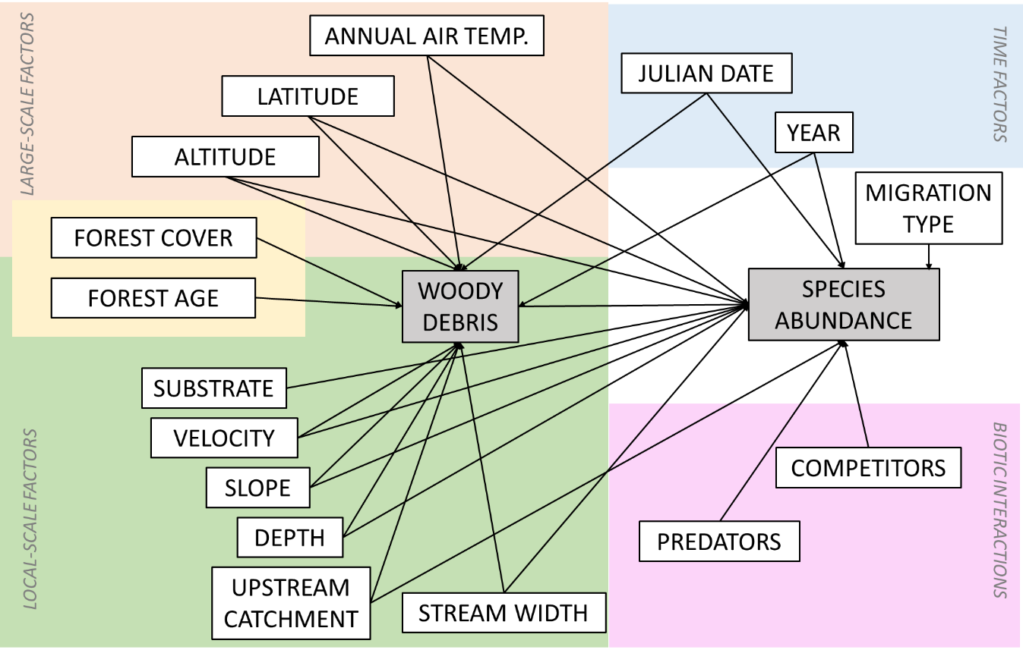

Fig. 2. Maps showing abundances of trout (A), salmon (B), sculpin fish (C) and woody debris (D) as averages over the years and rivers within 25×25km squares.

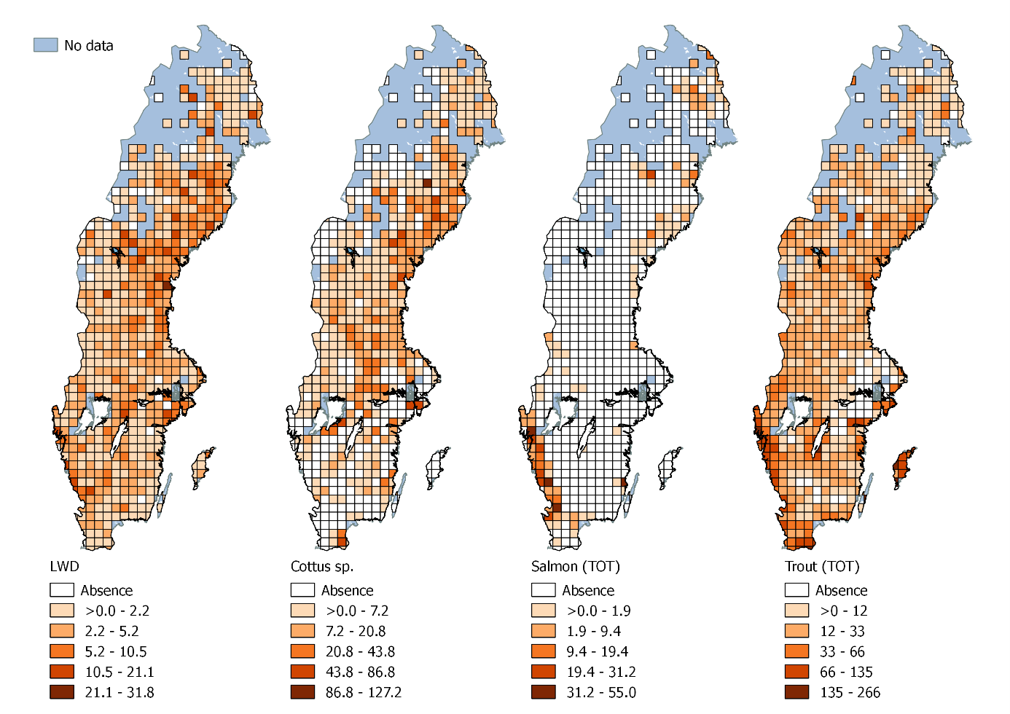

Fig. 3. Best-supported structural equation models representing significant relationships between all predictors and abundances of trout (A), salmon (B), and sculpin fish (C). Blue arrows indicate positive effects while red arrows indicate negative effects. Arrow widths are proportional to the standardized path coefficients. Conditional and marginal R2 values are shown for endogenous variables.

